**INDIAN ELECTRICITY WEBSITE**

**END TERM REPORT**



School of Computer Science Engineering

Lovely Professional University, Jalandhar

April 2020

**Project By : -**

1.Abhishek Paul Chandran

2.Palak Shivlani

3.Jaswanth Koduru

4.Sekhar Gangarapu

**Section : K19RD**

Student Declaration

This is to declare that this report has been written by me/us. No part of the report is copied from other sources. All information included from other sources have been duly acknowledged. I/we aver that if any part of the report is found to be copied. I/we are shall take full responsibility for it.

Section:K19RD

Group members

|  |  |  |
| --- | --- | --- |
| **NAME** | **REG. NO** | **ROLL NUMBER** |
| Abhishek Paul Chandran | 11915603 | 61 |
| Palak Shivlani | 11915617 | 62 |
| Jaswanth Koduru | 1195328 | 63 |
| Sekhar Gangarapu | 1193092 | 64 |

**Date**: 15/04/2020.

**BONAFIED CERTIFICATE**

Certified that this report “……*Indian Elctricity Website*……”is the bonafied work of “…Abhishek, Palak, Jaswanth and Sekhar…” who carried out the project work under the supervision.

<<signature of supervision>>

<<Name of supervisor>>

<<Academic Designation>>

<<ID of supervisor>>

<<Department of Supervisor>>

**Role of members**

1.Abhishek Paul

* My responsibility was of designing the layout of the home page
* My work includes adding images, text styling, finding and adding the content for the webpage, adding and making pdf files.

2.Palak Shivlani

* My responsibility was to combine all the sources which were gathered and code for the main page.
* My work was to design the webpage, adding hyperlinks, creating the classes and id’s using external css and adding them to the main page.

3.Jaswanth Koduru

* My responsibility was to design the hyperlinked pages and adding them to the home page.
* My work includes designing the backend hyperlink pages, creating tables.

4.Sekhar Gangarapu

My responsibility was to include the important tags,

Creating forms, background coloring and making dynamic feed, adding java script to the page.

**Description**

* Electricity is an essential requirement for all facets of our life. It has been recognized as a basic human need. It is a critical infrastructure on which the socio-economic development of the country depends. Supply of electricity at reasonable rate to rural India is essential for its overall development
* Indian Power sector is witnessing major changes. Growth of Power Sector in India since its Independence has been noteworthy. However, the demand for power has been outstripping the growth of availability.
* To meet the objective of rapid economic growth and “power for all” including household electrification, it is estimated that an investment of the order of Rs.9,00,000 crores price level would be required to finance generation, transmission, sub-transmission, distribution and rural electrification projects.
* All efforts will have to be made to improve the efficiency of operations in all the segments of the industry. Suitable performance norms of operations together with incentives and disincentives will need to be evolved along with appropriate arrangement for sharing the gains of efficient operations with the consumers

**Objectives**

The core objectives of the making of Indian Electricity website include :

* To provide easily accessible and a friendly interface for customers and provide a reliable base.
* Providing an uninterrupted platform to all categories of consumers, i.e. assurance of quality in power supply.
* Making convenient and multiple arrangement for payments services to all.
* Promptness in responding to the customers complaints and protecting the consumer rights.
* Supply of reliable and quality power of specified standards in an efficient manner and at reasonable rates.
* For accelerating and increasing the development of efficient power supply.
* Using different evolved technologies for the upliftment and advancement of way to provide electricity in an effective way.
* The key development objective of the power supply is the supply of electricity to all the areas including rural areas to get uninterrupted power twenty-four hours supply of quality power.

Glimpses of the Website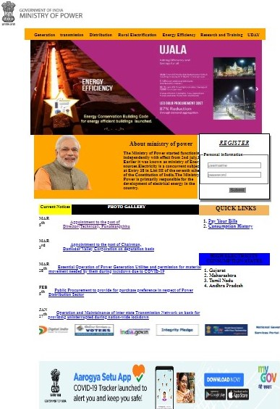

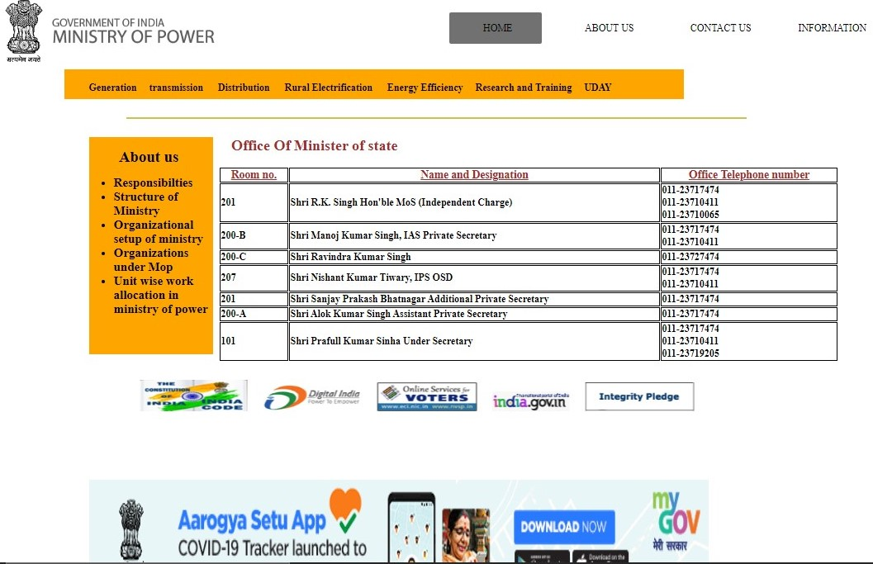

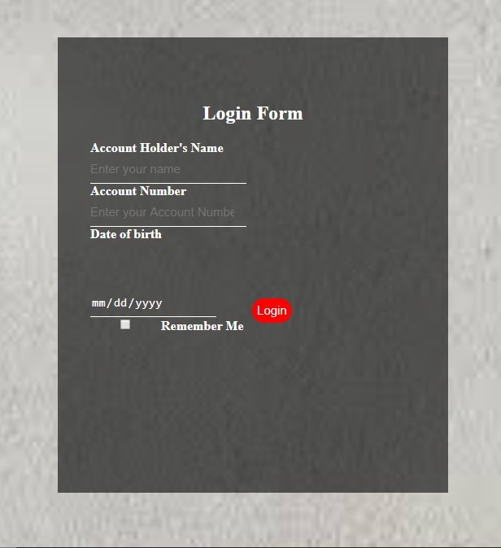

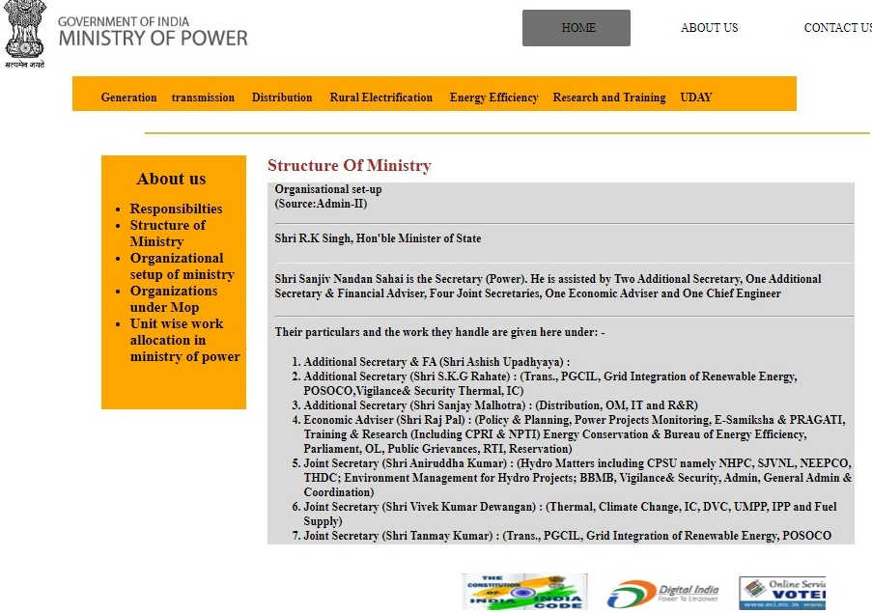

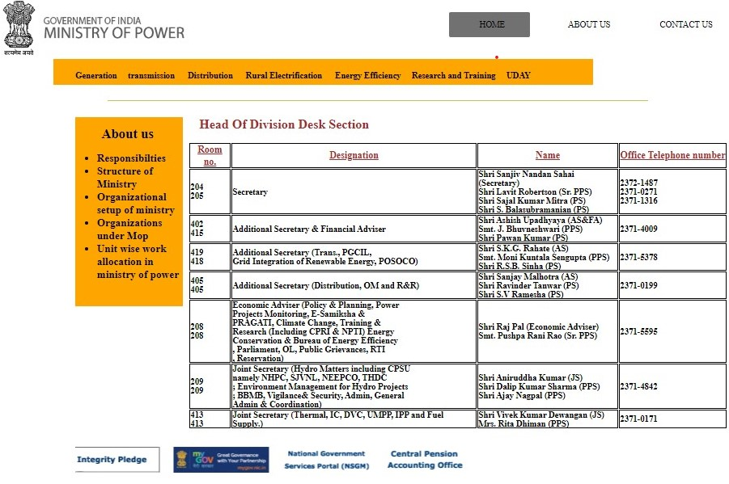

**Languages used for the Webpage**

**HTML**

HTML is the first layer and the core of any website, is used to wireframe of the webpage.

HTML stands for Hyper Text Markup Language.

HTML as a whole is the mark up that creates the basic elements we view on a website.

But HTML does have some limitations which have been overcome by using Cascading Style Sheet and Javascript.

**CSS**

CSS is a language that describes the style of a html document.

It describes how the HTML elements should be displayed.

It is one of the core languages and is standardized across all the web browsers to enhance and improve the abilities of HTML.

**JAVASCRIPT**

Javascript has been used in designing the webpage,

It has been to make the webpages user friendly and to make them dynamic.

We have used Atom Editor for this and Google Chrome as our base page.

**SWOT analysis of the project**

SWDT are the strengths, weaknesses, opportunities, and threats.

* **Strengths**: Versatile and dependable social service

A simple design to be used by users

Low labour costs

Quick way to access electricity details

* **Weaknesses**: At times, requests are difficult to handle

Security to the database is vulnerable

Poor hosting services

* **Opportunities**: More dependable due to 24*7 services

Easy access due to online mobile banking

Easy and fast transactions

Organized and time saving

* **Threats**: Software piracy

Vulnerable to cyber crimes

Security concerns in e-payments

Password threats